**STRING HANDING FUNCTIONS**

1.strcat(): used to combine two strings

Program:

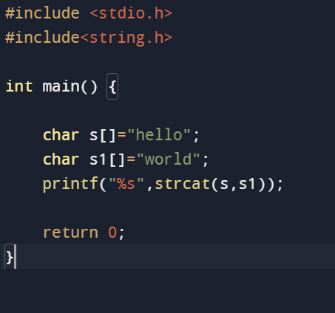

Output:



2.strlen(): used to show the length of string

Program:

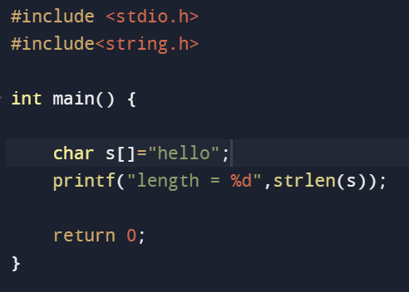

Output:



3.strcmp(): used to compare two strings

Program:

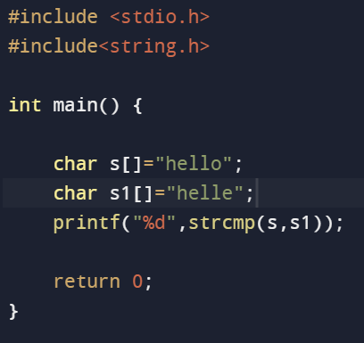

Output:



4.strcpy(): copies one string to another

Program:

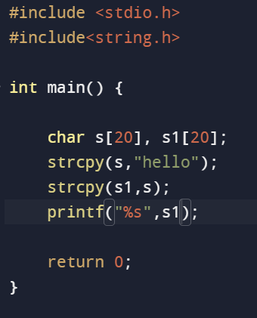

Output:



5.strlwr() & strupr() : used to convert the input to lower case and upper case

Program:

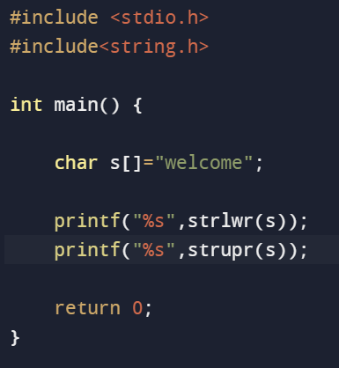

Output:

welcomeWELCOME